1. Hanging Gardens of Babylon

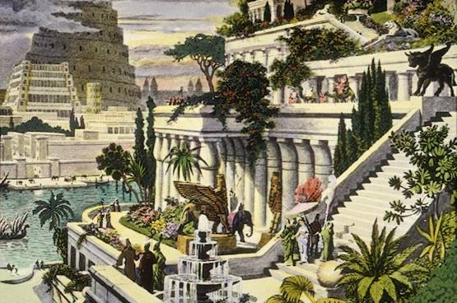

This hand-colored engraving by the 16th-century Dutch artist Martin Heemskerck depicts the fabled Hanging Gardens of Babylon, one of the Seven Wonders of the World. According to the tradition, the gardens did not hang, but grew on the roofs and terraces of the royal palace in Babylon. Nebuchadnezzar II, the Chaldean king, is supposed to have had the gardens built in about 600 BCE as a consolation to his Median wife, who missed the natural surroundings of her homeland. The Tower of Babel stands in the background.

2. Temple of Artemis

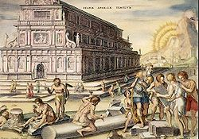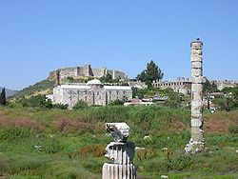
The Temple of Artemis (Greek: Ἀρτεμίσιον Artemision, also known less precisely as Temple of Diana, was a Greek temple dedicated to Artemis completed— in its most famous phase— around 550 BC at Ephesus (in present-day Turkey) under the Achaemenid dynasty of the Persian Empire. Nothing remains of the temple, which was one of the Seven Wonders of the Ancient World. There were previous temples on its site, where evidence of a sanctuary dates as early as the Bronze Age.
The old temple antedated the Ionic immigration by many years. Callimachus, in his Hymn to Artemis, attributed the origin of the temenos at Ephesus to the Amazons, whose worship he imagines already centered upon an image (bretas). In the seventh century the old temple was destroyed by a flood. Around 550 BC, they started to build the "new" temple, known as one of the wonders of the ancient world. It was a 120-year project, initially designed and constructed by the Cretan architect Chersiphron and his son Metagenes, at the expense of Croesus of Lydia.

3. The Great Pyramid of Giza
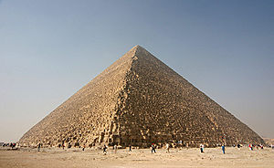

The Great Pyramid of Giza, in 2005. Built c. 2560 B.C., it is the oldest and largest of the three pyramids in the Giza Necropolis.
The Great Pyramid of Giza, also called Khufu's Pyramid or the Pyramid of Khufu, and Pyramid of Cheops, is the oldest and largest of the three pyramids in the Giza Necropolis bordering what is now Cairo, Egypt, and is the only remaining member of the Seven Wonders of the Ancient World. It is believed the pyramid was built as a tomb for Fourth dynasty Egyptian King Khufu (Cheops in Greek) and constructed over a 20 year period concluding around 2560 BC. The Great Pyramid was the tallest man-made structure in the world for over 3,800 years. Originally the Great Pyramid was covered by casing stones that formed a smooth outer surface, and what is seen today is the underlying core structure. Some of the casing stones that once covered the structure can still be seen around the base. There have been varying scientific and alternative theories regarding the Great Pyramid's construction techniques. Most accepted construction theories are based on the idea that it was built by moving huge stones from a quarry and dragging and lifting them into place.
There are three known chambers inside the Great Pyramid. The lowest chamber is cut into the bedrock upon which the pyramid was built and was unfinished. The so-called^{[1]} Queen's Chamber and King's Chamber are higher up within the pyramid structure. The Great Pyramid of Giza is the main part of a complex setting of buildings that included two mortuary temples in honor of Khufu (one close to the pyramid and one near the Nile), three smaller pyramids for Khufu's wives, an even smaller "satellite" pyramid, a raised causeway connecting the two temples, and small mastaba tombs surrounding the pyramid for nobles.

4. Statue of Zeus at Olympia
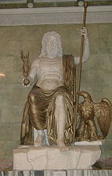

Roman Seated Zeus, marble and bronze (restored), following the type established by Phidias (Hermitage Museum)
The seated statue, some 12 metres (39 feet) tall, occupied the whole width of the aisle of the temple built to house it. "It seems that if Zeus were to stand up," the geographer Strabo noted early in the first century BC, "he would unroof the temple."^{[2]} Zeus was a chryselephantine sculpture, made of ivory and gold-plated bronze. No copy, in marble or bronze, has survived, though there are recognizable but approximate versions on coins of Elis and Roman coins and engraved gems^{[3]} but a very detailed description of the sculpture and the throne was recorded by the traveller Pausanias, in the second century AD. In the sculpture, he was wreathed with shoots of olive and seated on a magnificent throne of cedarwood, inlaid with ivory, gold, ebony, and precious stones. In Zeus' right hand there was a small statue of crowned Nike, goddess of victory, also chryselephantine, and in his left hand, a sceptre inlaid with metals, on which an eagle perched.^{[4]} Plutarch, in his Life of the Roman general Aemilius Paulus, records that the victor over Macedon, when he beheld the statue, “was moved to his soul, as if he had beheld the god in person,” while the Greek orator Dio Chrysostom declared that a single glimpse of the statue would make a man forget his earthly troubles.^{[5]}
The date of the statue, in the third quarter of the fifth century BC, long a subject of debate, was confirmed archaeologically by the rediscovery and excavation of Phidias' workshop.
According to a legend, when Phidias was asked what inspired him -- whether he climbed Mount Olympus to see Zeus, or whether Zeus came down from Olympus so that Phidias could see him -- the artist answered that he portrayed Zeus according to Book One, verses 528 - 530 of Homer´s Iliad ^{[6]}:

5. Mausoleum of Maussollos
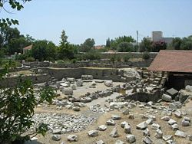 | 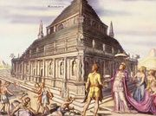
The Mausoleum site in ruins, as it is today | Fanciful interpretation of the Mausoleum, from a 1572 engraving by Marten eemskerk
The Tomb of Mausolus, Mausoleum of Mausolus or Mausoleum at Halicarnassus (in Greek, Μαυσωλεῖον της Ἁλικαρνασσοῦ) was a tomb built between 353 and 350 BC at Halicarnassus (present Bodrum, Turkey) for Mausolus, a satrap in the Persian Empire, and Artemisia II of Caria, his wife and sister. The structure was designed by the Greek architects Satyrus and Pythius.^{[1][2]} It stood approximately 45 metres (135 ft) in height, and each of the four sides was adorned with sculptural reliefs created by each one of four Greek sculptors — Leochares, Bryaxis, Scopas of Paros and Timotheus.^{[3]} The finished structure was considered to be such an aesthetic triumph that Antipater of Sidon identified it as one of his Seven Wonders of the Ancient World.

6. Colossus of Rhodes
.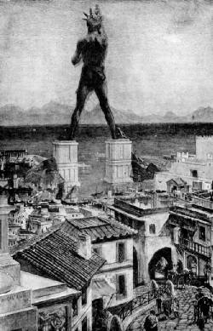
The Colossus of Rhodes was a statue of the Greek god Helios, erected on the Greek island of Rhodes by Chares of Lindos between 292 and 280 BC. It is considered one of the Seven Wonders of the Ancient World. Before its destruction, the Colossus of Rhodes stood over 30 meters (107 ft) high, making it one of the tallest statues of the ancient world.^{[1]}
Alexander the Great of Macedonia died at an early age in 323 BC without having had time to put into place any plans for his succession. Fighting broke out among his generals, the Diadochi, with four of them eventually dividing up much of his empire in the Mediterranean area. During the fighting, Rhodes had sided with Ptolemy, and when Ptolemy eventually took control of Egypt, Rhodes and Ptolemaic Egypt formed an alliance which controlled much of the trade in the eastern Mediterranean.
Antigonus I Monophthalmus was upset by this turn of events. In 305 BC he had his son Demetrius Poliorcetes, also a general, invade Rhodes with an army of 40,000; however, the city was well defended, and Demetrius—whose name "Poliorcetes" signifies the "besieger of cities"—had to start construction of a number of massive siege towers in order to gain access to the walls. The first was mounted on six ships, but these capsized in a storm before they could be used. He tried again with a larger, land-based tower named Helepolis, but the Rhodian defenders stopped this by flooding the land in front of the walls so that the rolling tower could not move.
In 304 BC a relief force of ships sent by Ptolemy arrived, and Demetrius's army abandoned the siege, leaving most of their siege equipment. To celebrate their victory, the Rhodians sold the equipment left behind for 300 talents^{[2]} (roughly US$360 million in today's money) and decided to use the money to build a colossal statue of their patron god, Helios. Construction was left to the direction of Chares, a native of Lindos in Rhodes, who had been involved with large-scale statues before. His teacher, the sculptor Lysippos, had constructed a 22 meter (70 ft) high^{[3]} bronze statue of Zeus at Tarentum

Rebuilding
In November 2008, it was announced that the Colossus of Rhodes was to be rebuilt. According to Dr. Dimitris Koutoulas, who is heading the project in Greece, rather than reproducing the original Colossus, the new structure will be a, "highly, highly innovative light sculpture, one that will stand between 60 and 100 metres tall so that people can physically enter it." The project is expected to cost up to €200m which will be provided by international donors and the German artist Gert Hof. The new Colossus will adorn an outer pier in the harbour area of Rhodes, where it will be visible to passing ships. Koutoulas said, "Although we are still at the drawing board stage, Gert Hof's plan is to make it the world's largest light installation, a structure that has never before been seen in any place of the world."^{[11]}

7. Lighthouse of Alexandria
Lighthouse of Alexandria
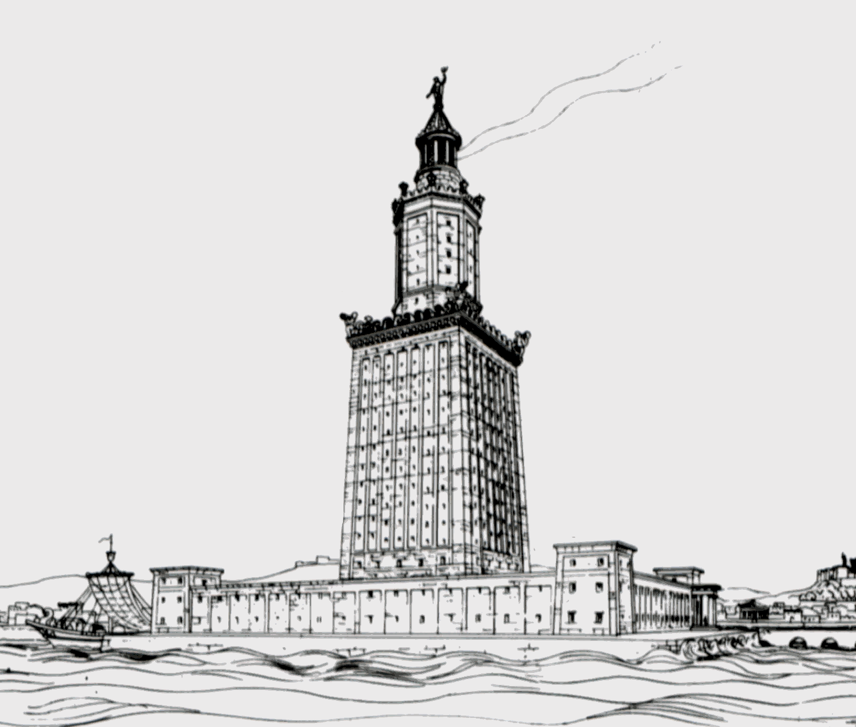
A drawing of the lighthouse by German
archaeologist Prof. H. Thiersch (1909).

The lighthouse of Alexandria (or The Pharos of Alexandria, Greek: ὁ Φάρος τῆς Ἀλεξανδρείας) was a tower built in the 3rd century BC (between 285 and 247 BC) on the island of Pharos in Alexandria, Egypt to serve as that port's landmark, and later, its lighthouse.
With a height variously estimated at between 115 and 150 m (380 and 490 ft) it was among the tallest man-made structures on Earth for many centuries, and was identified as one of the Seven Wonders of the Ancient World by Antipater of Sidon. It may have been the third tallest building after the two Great Pyramids (of Khufu and Khafra) for its entire life. Some scholars estimate that would make the tower the tallest building up to the 14th century.

History
Pharos was a small island just off the coast of Alexandria. It was linked to the mainland by a man-made connection named the Heptastadion, which thus formed one side of the city's harbor. As the Egyptian coast is very flat and lacking in the kind of landmark used at the time for navigation, a marker of some sort at the mouth of the harbour was deemed necessary - a function the Pharos was initially designed to serve. Use of the building as a lighthouse, with a fire and reflective mirrors at the top, is thought to date to around the 1st century AD, during the Roman period. Prior to that time the Pharos served solely as a landmark or day beacon.

8. Wonders of the Medieval World
Many lists of "wonders of the world" are said to have existed during the Middle Ages, although it is unlikely that these lists originated at that time because the word medieval was not even invented until the Enlightenment-era, and the concept of a "Middle Age" did not become popular until the 16th century. Brewer's refers to them as "later list[s]"^{[2]} suggesting the lists were created after the Middle Ages.
Many of the structures on these lists were built much earlier than the Medieval Ages, but were well known. These lists go by names such as "Wonders of the Middle Ages" (implying no specific limitation to seven), "Seven Wonders of the Middle Ages", "Medieval Mind" and "Architectural Wonders of the Middle Ages".
Typically representative of the seven greatest wonders of the Medieval world are:^{[3][4][5][2]}
- Stonehenge
- Colosseum
- Catacombs of Kom el Shoqafa
- Great Wall of China
- Porcelain Tower of Nanjing
- Hagia Sophia
- Leaning Tower of Pisa

9. Wonders of the modern world
Many lists have been made of the greatest structures built during modern times or of the greatest wonders existing today. Some of the most notable lists are presented below.

American Society of Civil Engineers
The American Society of Civil Engineers compiled a list of wonders of the modern world:^{[10]}
Wonder | Date Started | Date Finished | Locations
Channel Tunnel | December 1, 1987 | May 6, 1994 | Strait of Dover, between the United Kingdom and France
CN Tower | February 6, 1973 | June 26, 1976, tallest freestanding structure in the world until September 12, 2007. Surpassed by Burj Dubai | Toronto, Ontario, Canada
Empire State Building | January 22, 1930 | May 1, 1931, Tallest structure in the world 1931-1967. First building with 100+ stories. | New York, NY, U.S.
Golden Gate Bridge | January 5, 1933 | May 27, 1937 | Golden Gate Strait, north of San Francisco, California, U.S.
Itaipu Dam | January 1970 | May 5, 1984 | Paraná River, between Brazil and Paraguay
Delta Works | 1950 | May 10, 1997 | Netherlands
Panama Canal | January 1, 1880 | January 7, 1914 | Isthmus of Panama

10. New 7 Wonders Foundation's seven wonders of the world
In 2001 an initiative was started by the Swiss corporation New7Wonders Foundation to choose the New Seven Wonders of the World from a selection of 200 existing monuments for profit.^{[11]} Twenty-one finalists were announced January 1, 2006.^{[12]} Egypt was not happy with the fact that the only original wonder would have to compete with the likes of the Statue of Liberty, the Sydney Opera House, and other landmarks; and called the project absurd. To solve this, Giza was named an honorary Candidate.^{[13]} The results were announced on July 7, 2007 in Benfica's stadium in a big ceremony in Lisbon, Portugal,^{[14]} and are:
Wonder | Date of construction | Location
Great Wall of China | 5th century BCE – 16th century CE | China
Petra | 6th century BCE | Jordan
Christ the Redeemer | Opened 12 October 1931 | Brazil
Machu Picchu | c.1450 | Peru
Chichen Itza | c.600 | Mexico
Roman Colosseum | Completed 80 CE | Italy
Taj Mahal | Completed c.1648 | India
Great Pyramid (Honorary Candidate) | Completed c.2560 BCE | Egypt

11. USA Today's New Seven Wonders
In November 2006 the American national newspaper USA Today in place in the American television show Good Morning America revealed a list of New Seven Wonders as chosen by six judges.^{[15]} The wonders were announced one per day over a week on Good Morning America. An eighth wonder was chosen on November 24 from viewer feedback.^{[16]}
Number | Wonder | Location
1 | Potala Palace | Lhasa, Tibet, China
2 | Old City of Jerusalem | Jerusalem, Israel
3 | Polar ice caps | Polar regions
4 | Papahānaumokuākea Marine National Monument | Hawaii, United States
5 | Internet | Everywhere
6 | Maya ruins | Yucatán Peninsula, México
7 | Great Migration of Serengeti and Masai Mara | Tanzania and Kenya
8 | Grand Canyon (viewer-chosen eighth wonder) | Arizona, United States

12. Seven Wonders of the Industrial World
British author Deborah Cadbury wrote Seven Wonders of the Industrial World, a book telling the stories of seven great feats of engineering of the nineteenth and early twentieth centuries. In 2003 the BBC made a seven-part documentary series on the book, with each episode dramatising the construction one of the wonders. The seven industrial wonders are:
- SS Great Eastern
- Bell Rock Lighthouse
- Brooklyn Bridge
- London sewerage system
- First Transcontinental Railroad
- Panama Canal
- Hoover Dam

13. Travel wonders of the world
Travel writer Howard Hillman is one of many such writers who has compiled lists of the top man-made^{[17]} and natural^{[18]} tourist travel wonders of the world:

14. Man-made travel wonders
- Giza pyramid complex
- Great Wall of China
- Taj Mahal
- Machu Picchu
- Bali
- Angkor Wat
- Forbidden City
- Bagan Temples & Pagodas

Chichen Itza | Yucatán, Mexico | 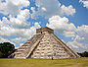
Christ the Redeemer | Rio de Janeiro, Brazil | 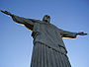
Colosseum | Rome, Italy | 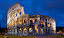
Great Wall of China | China | 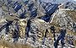
Machu Picchu | Aguas Calientes, Perú | 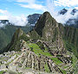
Petra | Jordan | 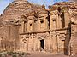
Taj Mahal | Agra, India | 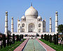
And one listing has honorary status: Giza Pyramid Complex  (The last remaining ancient wonder of the world) | Cairo, Egypt | 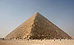
New Seven Wonders of the World

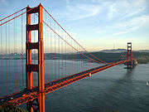 Golden Gate Bridge | 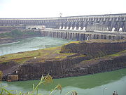 The Itaipu hydroelectric dam on the Paraná River
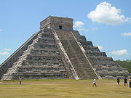 Chichen Itza | 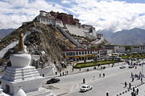 Potala Palace
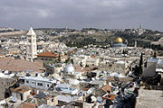 Old City of Jerusalem | 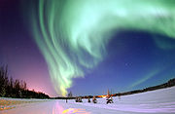 The Aurora Borealis or Northern Lights
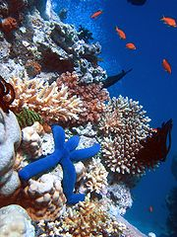 The Great Barrier Reef | 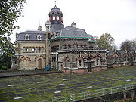 The London sewerage system's original Abbey Mills pumping station

